**Assignment #1**

소속: 컴퓨터학부 학번: 이름: 전현승 제출일시: 2019/10/21

1. Consider families of three children, observing whether each child is a bot or a girl. There are eight possibilities for each family: GGG, GGB, GBG, BGG, GBB, BGB, BBG, BBB, where each outcome is listed in order of birth. We can define the random variable $X$ to be the function that assigns to each outcome the number of boys; and we can define $Y$ to be the number of girls. If we are interested in the number of times there is a switch from girl to boy or from boy to girl, we can define the random variable $Z$ to be the number of changes in sequence. Consider the model where the sex of each child is independent of the sex of the previous children, where the chance a boy birth is 0.52, and the chance of a girl is 0.48. Draw a graph to represent the CDF for family planning, when we have a probability mass function and the cumulative distribution function as following:

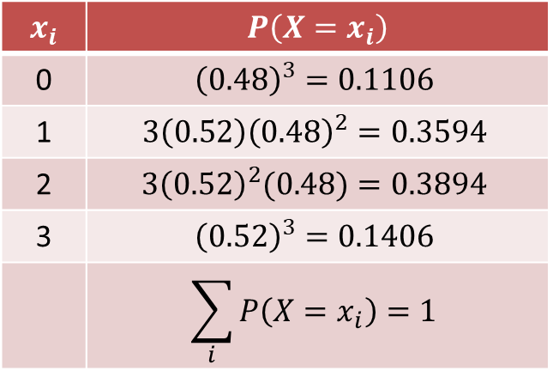 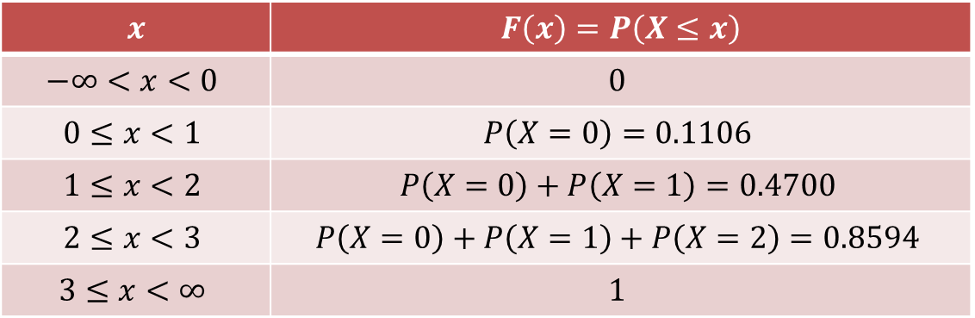

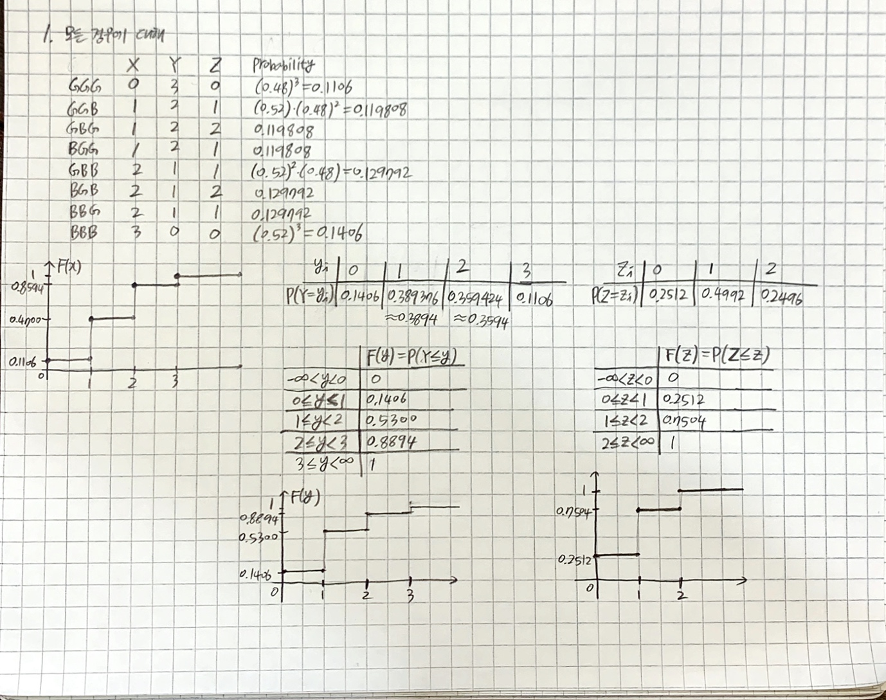

2. A company has one position available for which eight applicants have made the short list. The company’s strategy is to interview the applicants sequentially and to make an offer immediately to anyone they feel is outstanding (without interviewing the additional applicants). If none of the first seven applicants interviewed is judged to be outstanding, the eighth applicant is interviewed and then the best of the eight applicants is offered the job. The company is interested in how many applicants will need to be interviewed under this strategy. If a random variable $X$ is defined as the number of applicants interviewed and we have the cumulative distribution function as following, write a tabular representation of PMF and draw a graphical representation corresponding to PMF

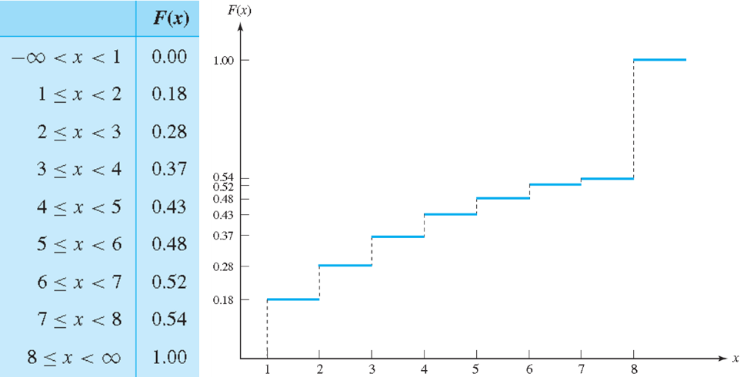

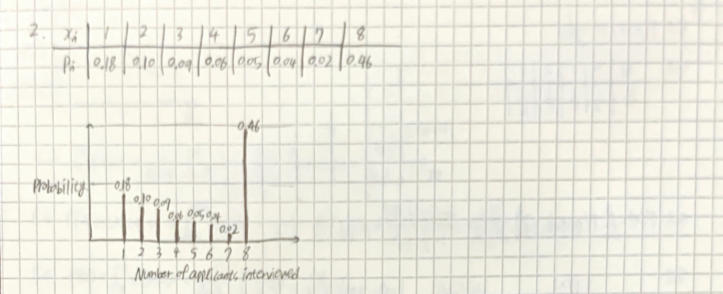

3. In the power plant operation example, please make a table for the cumulative function value of an example of power plant operation. Furthermore, draw the graph of cumulative function

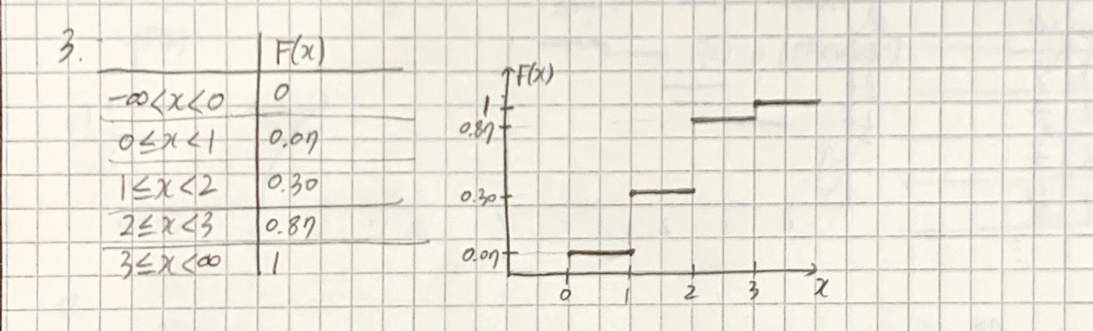

4. An office has four copying machines, and the random variable 𝑋 measure how many of them are in use at a particular moment in time. Answer the following questions.

4.1. Write the sample space 𝑆

4.2. Write the values taken by the random variable 𝑋 as set representation

4.3. Suppose that 𝑃(𝑋=0)=0.08, 𝑃(𝑋=1)=0.11, 𝑃(𝑋=2)=0.27, 𝑃(𝑋=3)=0.33, What is 𝑃(𝑋=4)?

4.4. Draw a line graph of the probability mass function

4.5. Construct and plot the cumulative distribution function

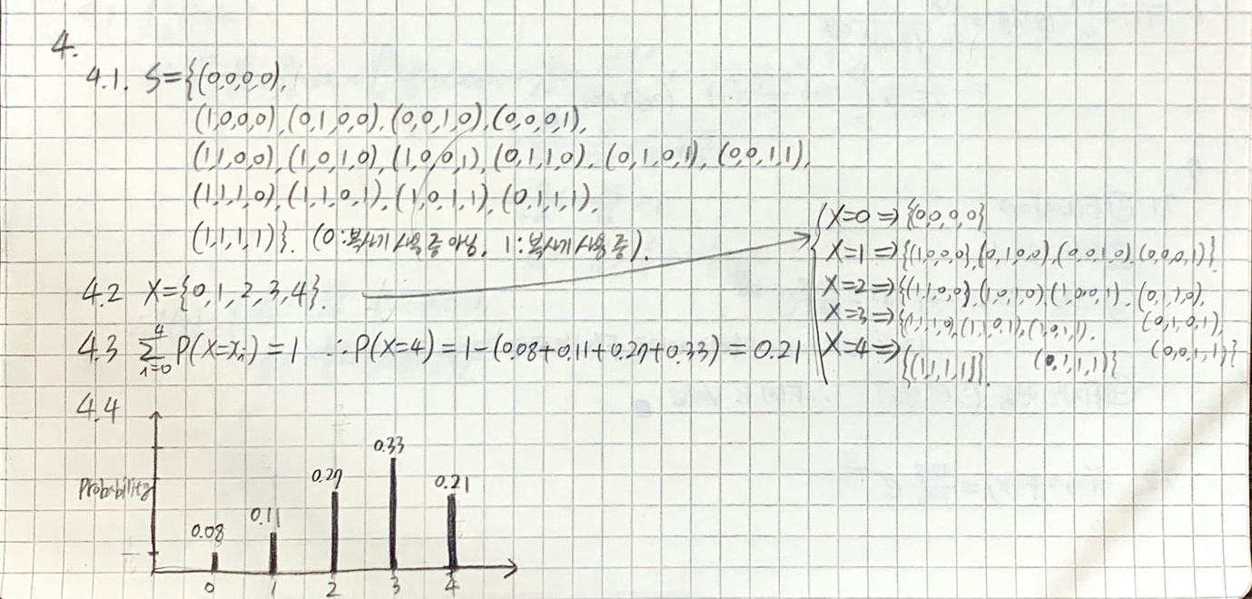

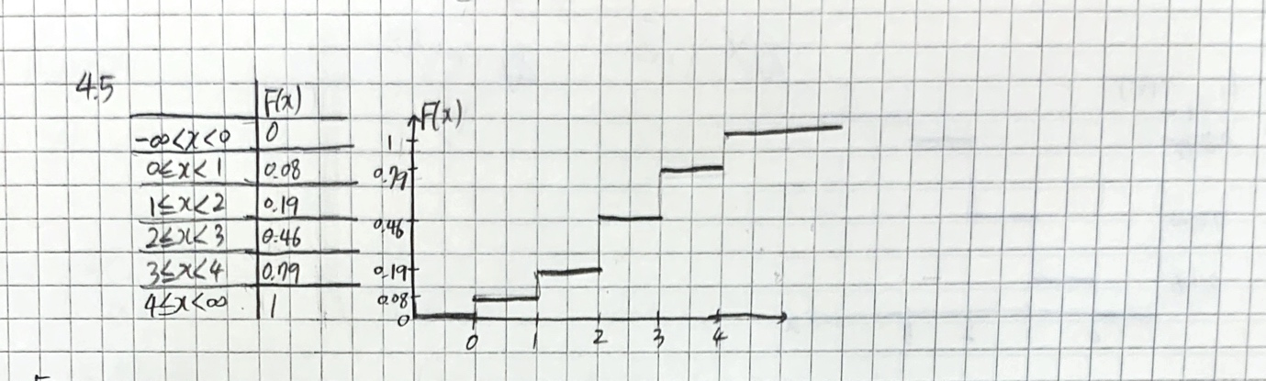

5. (Games of chance) Toss a fair coin repeatedly until it comes up heads. The outcome set(sample space) is $S=\left\{H,TH,TTH,…\right\}$. Let $X$ be the number of tails before the first head appears. Answer the following questions.

5.1. Write the PMF as specific formula

5.2. Draw a table and a graph to represent the PMF

5.3. Write the CDF as specific formula

5.4. Draw a table and a graph to represent the CDF

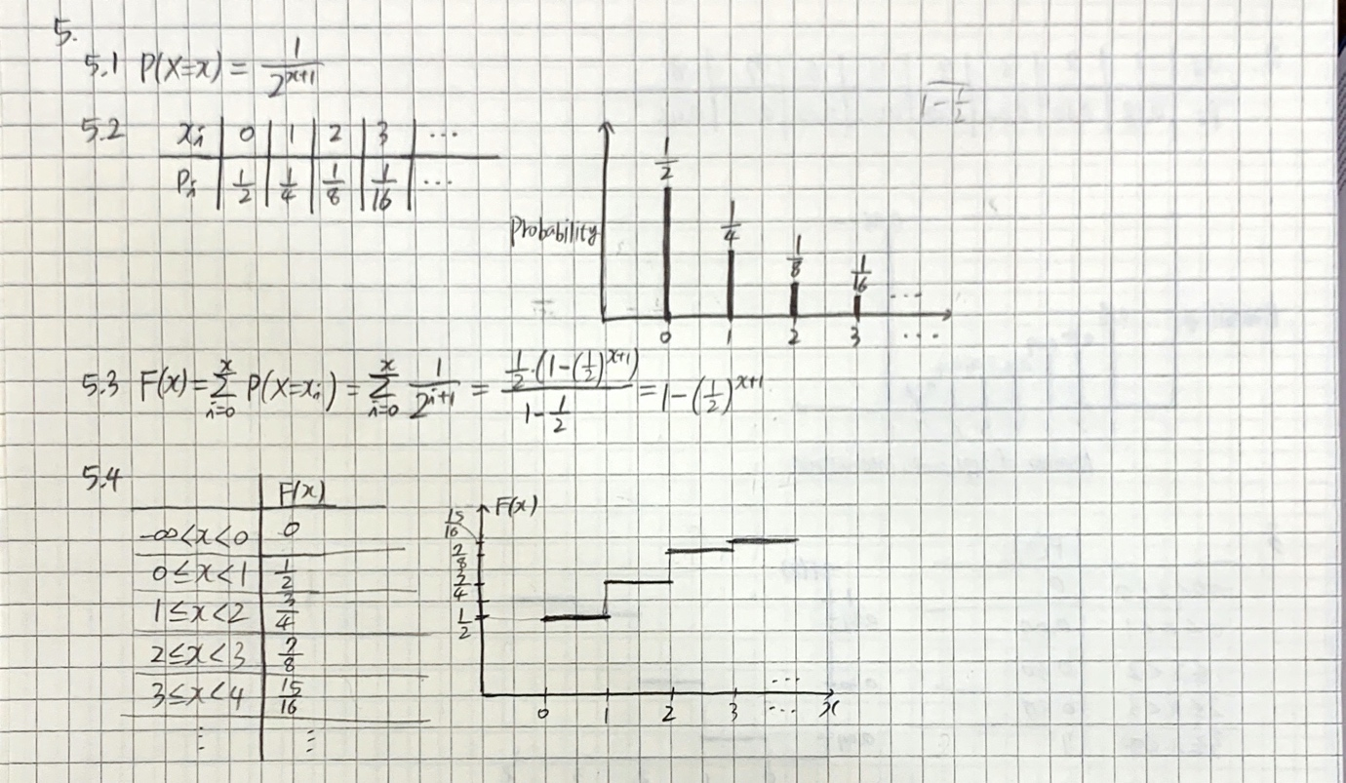

6. In the battery failure time example, Let a probability density function be $f(x)=\frac{2}{{\left(x+1\right)}^{3}}$, for 0≤𝑥<∞. Find the cumulative distribution function.

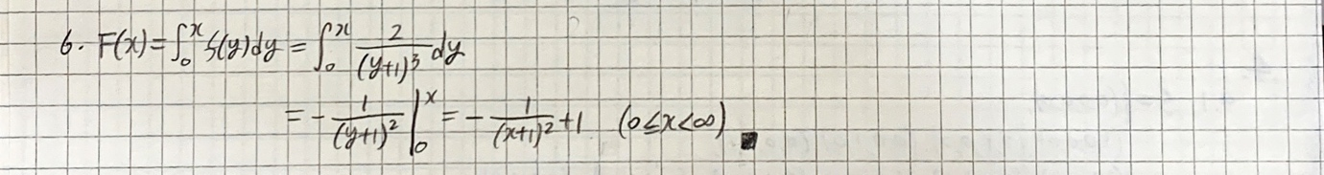

7. In the concrete slab breaking strengths example, Let the cumulative distribution function be $F(x)=3.856-12.8e^{-\frac{x}{100}}$, for 120≤𝑥≤150. Answer the following questions.

7.1. Is this valid?? Show that the CDF is valid.

7.2. Find the probability density function from the CDF

7.3. Draw a graph for the PDF and CDF

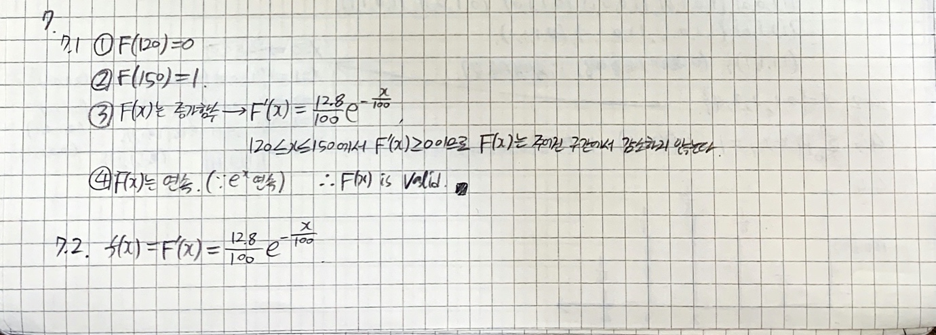

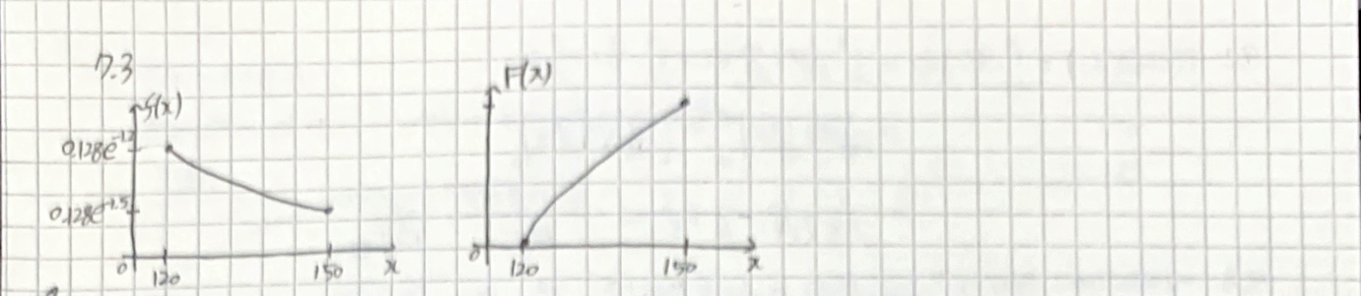

8. A random variable $X$ takes values between 4 and 6 with a probability density function $f\left(x\right)=\frac{1}{x\ln\left(1.5\right)}$, for $4≤x≤6$ and $f\left(x\right)=0$ elsewhere. Answer the following questions.

8.1. Make a sketch of the probability density function

8.2. Check that the total area under the probability density function is equal to 1.

8.3. What is $P\left(4.5≤X≤5.5\right)$?

8.4. Construct and sketch the cumulative distribution function.

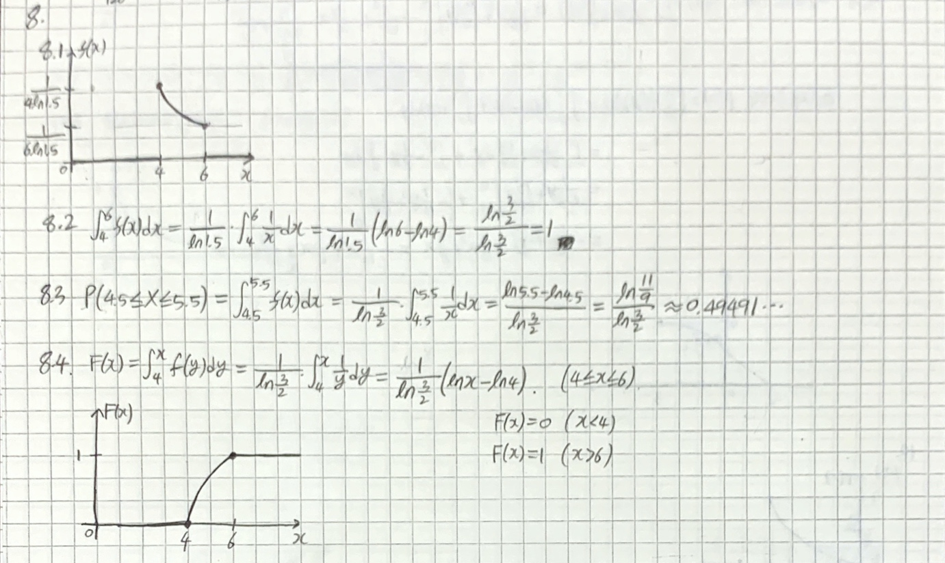

9. A random variable $X$ takes values between -2 and 3 with a probability density function $f\left(x\right)=\left\{\begin{matrix}\frac{15}{64}+\frac{x}{64} & -2≤x≤0 \\ \frac{3}{8}+cx & 0≤x≤3\end{matrix}\right.$, and $f\left(x\right)=0$ elsewhere. Answer the following questions.

9.1. Find the value of $c$ and sketch the probability density function.

9.2 What is $P(-1≤X≤1)$?

9.3. Construct and sketch the cumulative distribution function.

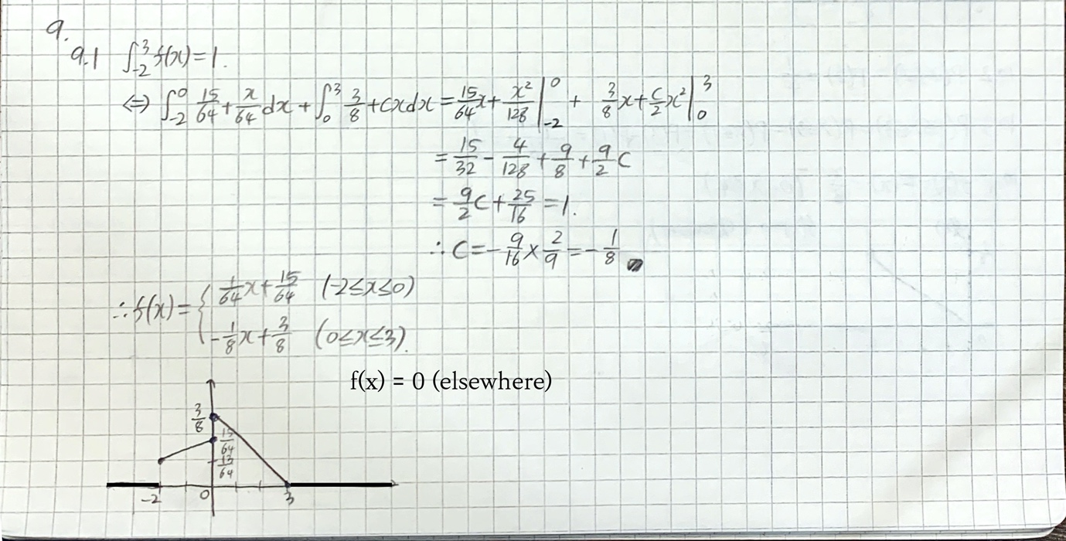

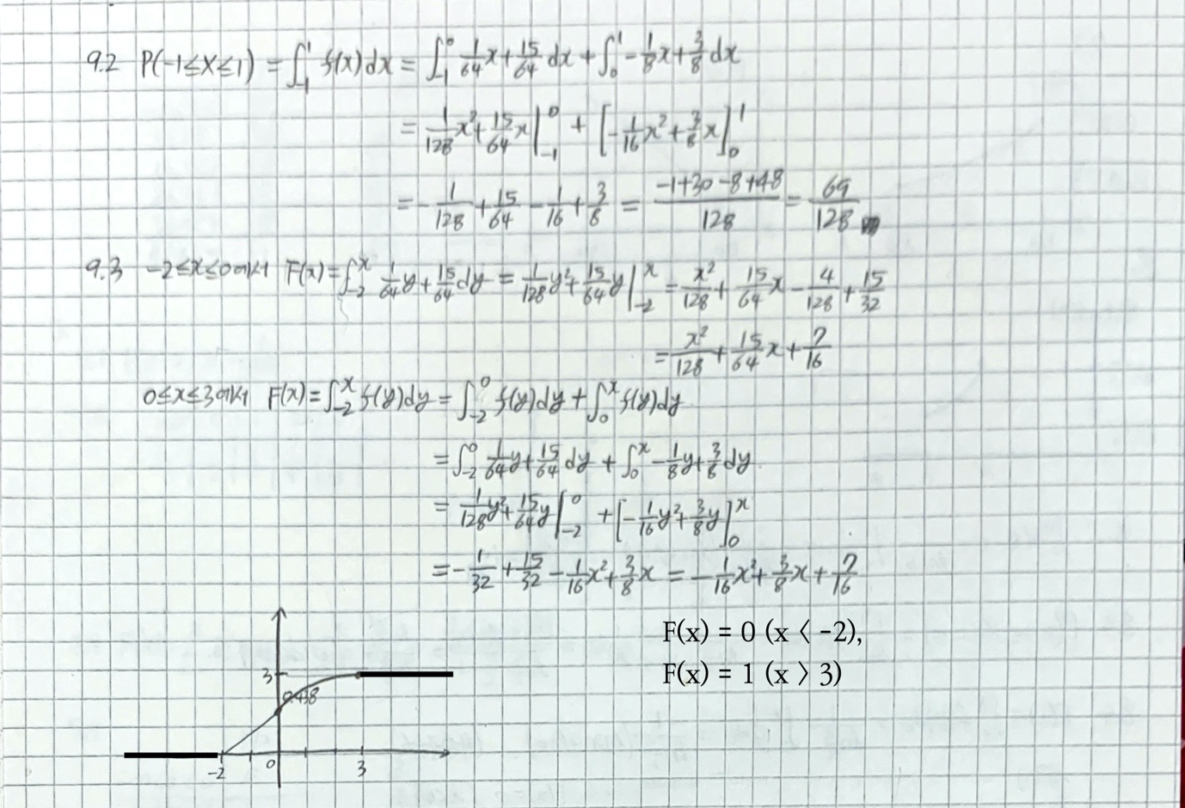

10. A random variable $X$ takes values between 0 and 4 with a cumulative distribution function $F\left(x\right)=\frac{x^{2}}{16}$, for $0≤x≤4$. Answer the following questions.

10.1. Sketch the cumulative distribution function.

10.2. What is $P\left(X≤2\right)$?

10.3. What is $P\left(1≤X≤3\right)$?

10.4. Construct and sketch the probability density function.

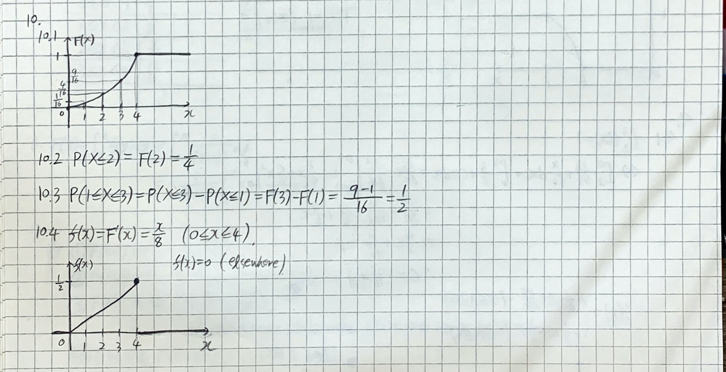

11. A random variable $X$ takes values between 0 and $∞$ with a cumulative distribution function $F\left(x\right)=A+{Be}^{-x}$ for $0≤x≤∞$. Answer the following questions.

11.1. Find the values of $A$ and $B$ and sketch the cumulative distribution function.

11.2. What is $P\left(2≤X≤3\right)$?

11.3. Construct and sketch the probability density function.

